# Office Collaborator

#### A PROJECT REPORT

#### Submitted By

**Vishal Singh**

**(University Roll No: - 2000290140135)**

**Anubhav Maurya**

**(University Roll No: - 2000290140022)**

#### Uddeshya Sharma

**(University Roll No: - 2000290140127)**

#### Vaibhav Srivastava

**(University Roll No: - 2000290140129)**

#### Submitted in partial fulfilment of the Requirements for the Degree of

**MASTER OF COMPUTER APPLICATIONS**

**Under the Supervision of Mr. Ankit Verma Associate Professor**



**Submitted to**

**DEPARTMENT OF COMPUTER APPLICATIONS**

#### KIET Group of Institutions, Ghaziabad Uttar Pradesh-201206

**(JAN 2022)**

**CERTIFICATE**

Certified that **Vishal Singh<200029014005820>,Anubhav Maurya<** **200029014005707>, Uddeshya Sharma<** **200029014005812>, Vaibhav Srivastava<** **200029014005814>** have carried out the project work having “**Office Collaborator**” for Master of Computer Applications from Dr.

A.P.J. Abdul Kalam Technical University (AKTU**)** (formerly UPTU), Technical University, Lucknow under my supervision. The project report embodies original work, and studies are carried out by the student himself / herself and the contents of the project report do not form the basis for the award of any other degree to the candidate or to anybody else from this or any other University/Institution.

**Date:**

**Vishal Singh (2000290140135)**

**Anubhav Maurya (2000290140022)**

**Uddeshya Sharma (2000290140127)**

**Vaibhav Srivastava (2000290140129)**

This is to certify that the above statement made by the candidate is correct to the best of my knowledge.

Date:

**Mr. Ankit Verma Associate Professor**

**Department of Computer Applications KIET Group of Institutions, Ghaziabad**

**Signature of Internal Examiner Signature of External Examiner**

**Dr. Ajay Shrivastava**

**Head, Department of Computer Applications KIET Group of Institutions, Ghaziabad**

## ACKNOWLEDGEMENTS

Success in life is never attained single handedly. My deepest gratitude goes to my thesis supervisor, **Mr. Ankit Verma** for his guidance, help and encouragement throughout my research work. Their enlightening ideas, comments, and suggestions.

Words are not enough to express my gratitude to **Dr. Ajay Kumar Shrivastava**, Professor and Head, Department of Computer Applications, for his insightful comments and administrative help at various occasions.

Fortunately, I have many understanding friends, who have helped me a lot on many critical conditions.

Finally, my sincere thanks go to my family members and all those who have directly and indirectly provided me moral support and other kind of help. Without their support, completion of this work would not have been possible in time. They keep my life filled with enjoyment and happiness.

**Vishal Singh**

**Anubhav Maurya**

**Uddeshya Sharma**

**Vaibhav Srivastava**

**List of Content**

1. Introduction 06
   1. Purpose 06
   2. Scope 06
   3. Overview 07
   4. Goals Of proposed System 07
   5. Background 08
   6. Project Requirements 09
   7. Technology Used 09
2. Feasible Study 10-12
   1. Technical Feasibility 10
   2. Economical Feasibility 11
   3. Operational Feasibility 12
   4. Schedule Feasibility 12
3. Architectural Design 13-18
   1. ER diagram 13-14
   2. Data flow diagram 15-16
   3. Use Case Diagram 17-18
4. System Design 19-21
   1. User table 19
   2. Personal Table 20
   3. Education Table 20
   4. Other Table 21
5. Implementation 22-44

5.1 Code 22-39

5.1.1 Sign up 22-24

5.1.2 Login 24-26

* + 1. Personal 26-29
    2. Education 29-33
    3. Experience 33-37
    4. Project 37-39
  1. Test case 40
  2. Snapshot 41-43
     1. Sign up 41
     2. Login 41
     3. Personal 42
     4. Education 42
     5. Experience 43
     6. Project 43

## LIST OF TABLES

|  |  |  |
| --- | --- | --- |
| **Table No.** | **Name of Table** | **Page** |
| 4.1 | Admin Table |  |
| 4.2  4.3 | EmpDetail Table  Project Table |  |
| 4.4 | ProjectDetails Table |  |
| 4.5 | UpdateDetails Table |  |

**Introduction**

Resume is the first meeting between you and a prospective employer more often now than ever. So, how do you want to be remembered? Wrinkled and unorganized. Neat and structured. Long and boring. Precise and interesting. Companies do not have the time to interview every applicant that is interested in the job. If they did, there would not be a company to work for. They use an eliminating process. That's right - resumes. When a job seeker wants to apply for a job online then generally, he/she needs to attach his/her resume with the email. Online Resume Building System provides the users the popular resume formats & a better way to show their resumes to the employers. A job seeker does not need to attach a resume with every email, he/she just must include the URL of his/her resume and the employer can view the resume online by clicking on the link and can download as well.

# Purpose

Purpose of Online Resume Builder is to provide a way to the customers to design their resumes according to their requirements.

1. Creating resumes online.
2. Customizing the look and details.

# Scope

Online Resume Builder can be used in accordance with the requirements of the customers. Customers can customize their resumes with their choice of themes & details. The services are hard to be defeated by the competitors as the system is providing the customers exactly what they want.

# Overview

Project is related to Online Resume Building.

* + This project maintains 1 types of users.
  + Users (Customers)

Facilities provided by this project are as follows

* + Details of customers are recorded.
  + Update of data is easy.
  + Flow of information is fast and easy.
  + Customers can login to their accounts and view & update their data.

# Goals of Proposed System

1. **Planned approach towards working: -** The working of the system will be well planned and organized. The data will be stored properly in data stores, which will help in retrieval of information as well as its storage.
2. **Accuracy: -** The level of accuracy in the proposed system will be higher. All operation would be done correctly, and it ensures that whatever information is coming from the system is accurate.
3. **Reliability: -** The reliability of the proposed system will be high due to the above stated reasons. The reason for the increased reliability of the system is that now there would be proper storage of information.
4. **No redundancy: -** In the proposed system utmost care would be that no information is repeated anywhere, in storage or otherwise. This would assure economic use of storage space and consistency in the data stored.
5. **Immediate Retrieval of Information: -** The main objective of proposed system is to provide for a quick and efficient retrieval of information. Any type of information would be available whenever the user requires.
6. **Immediate storage of information: -** In manual system there are many problems to store & update the large amount of information
7. **Easy to operate: -** The system should be easy to operate and should be such that it can be easily understood by a new user.

# Background

Online Resume Builder is a system which allows the customers to design their resumes in accordance with their requirements. System provides facilities like…

* + - Customizing the resumes according to the user requirements.
    - Editing the design.
    - Choosing from latest professional designers.
    - Viewed resume notification for the customers.

Various operations done in the system are as follows…

* + - Registering customers.
    - Access to viewers/employers is allowed for public/shared data only. Writing resumes.
    - Editing in design.
    - Keeping track of latest formats of resumes. Viewed resume notification

# Project Requirements

**Software requirements**

|  |  |
| --- | --- |
| **Operating system** | **Software requirement** |
| Windows 7,8,10,  Linux, or any other higher version | Google chrome,  internet explorer, or any web browser |

|  |  |  |  |
| --- | --- | --- | --- |
| **Hardware requirements** | | | |
|  | **Processor** | **RAM** |  |
|  | Core i3 and above | 2GB or more |  |

* 1. **Technologies used:**

This project will be an Internet application to be developed in following tools and technologies.

* + Front End
    - Web technology: - React.js, JavaScript
    - Languages used: - JavaScript, HTML5, CSS
    - Development tool: - VS Code
  + Back End
    - PHP, MySql

# Feasibility Study

Depending on the results of the initial investigation the survey is now

expanded to a more detailed feasibility study. “FEASIBILITY STUDY” is a test of system proposal according to its workability, impact of the organization, ability to meet needs and effective use of the resources. It focuses on these major questions: What are the user’s demonstrable needs and how does a system meet them? What resources are available for given system?  What are the likely impacts of the system on the organization? Whether it is worth to solve the problem? During feasibility analysis for this project, following primary areas of interest are to be considered. Investigation and generating ideas about a new system does this. Steps in feasibility analysis Eight steps involved in the feasibility analysis are: Form a project team and appoint a project leader

Prepare system flowcharts.

Enumerate potential proposed system.

Define and identify characteristics of proposed system.

Determine and evaluate performance and cost effectiveness of each proposed system.

Weight system performance and cost data.

Select the best-proposed system. Prepare and report final project directive to management.

# Technical Feasibility

Technical feasibility is the study of resource availability that may affect the ability to achieve an acceptable system. This evaluation determines whether the technology needed for the proposed system is available or not. Can the work for the project be done with current equipment existing software technology & available personal?

* + - Can the system be upgraded if developed?
    - If new technology is needed, then what can be developed? This is concerned with specifying equipment and software that will successfully satisfy the user requirement. The technical needs of the system may include Front-end and back-end selection An important issue for the development of a project is the selection of suitable

front-end and back-end. When we decided to develop the project, we went through an extensive study to determine the most suitable platform that suits the needs of the organizations as well as helps in development of the project. The aspects of our study included the following factors. Front-end selection:

* + - It must have a graphical user interface that assists users that are not an advanced user of computer.
    - Scalability and extensibility.
    - Flexibility.
    - Robustness.
    - According to the organization requirement and the culture
    - Must provide excellent reporting features with good printing support.
    - Platform independent.
    - Easy to debug and maintain.
    - Event driven programming facility.
    - Front end must support some popular back end like Ms Access

# Economical Feasibility

Economic justification is generally the “Bottom Line” consideration for most systems. Economic justification includes a broad range of concerns that includes cost benefit analysis. In this we weight the cost and the benefits associated with the candidate system and if it suits the basic purpose of the organization i.e., profit making, the project is making to, the analysis and design phase

The financial and the economic questions during the preliminary investigation are verified to estimate the following: The cost to conduct a full system investigation. The cost of hardware and software for the class of application being considered. The benefits in the form of reduced cost.

The proposed system will give the minute information, as a result the performance is improved which in turn may be expected to provide increased profits. This feasibility checks whether the system can be developed with the available funds. Online Resume Builder does not require enormous amount of money to be developed. This can be done economically if planned judicially, so it is economically feasible. The cost of project depends upon the number of man-hours required.

# Operational Feasibility

It is mainly related to human organizations and political aspects. The points to be considered are:

What changes will be brought with the system? What organization structures are disturbed?

What new skills will be required? Do the existing staff members have these skills? If not, can they be trained in due course of time? The system is operationally feasible as it very easy for the End users to operate it

# Schedule Feasibility

Time evaluation is the most important consideration in the development of project. The time schedule required for the development of this project is very important since more development time effect machine time, cost and cause delay in the development of other systems. Office Collaborator can be developed in the considerable amount of time.

# 3.Architectural Design

Data Base

Online Resume Builder

Architectural design represents the structure of data and program components that are required to build a computer-based system. It considers the architectural style that the system will take, the structure and properties of the components that constitute the system, and the interrelationships that occur among all architectural components of a system.

Customer

# ER Diagram

The object/relationship pair is the cornerstone of the data model. These pairs are represented graphically using E-R diagrams. A set of primary components are identified for the ERD: data objects, attributes, relationships, and various type indicators. The primary purpose of ERD is to represent data objects and their relationships

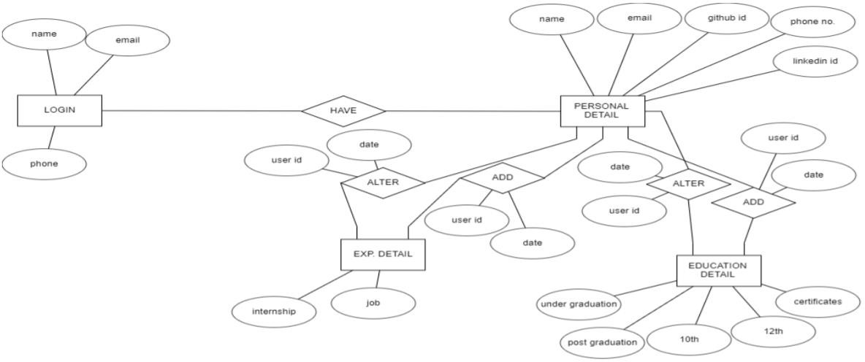

# DFD (Data Flow Diagram)

The data flow diagram enables the software engineer to develop models of the information domain and functional domain at the same time. As the DFD is refined into greater level of detail, the analyst performs an implicit functional decomposition of the system. At the same time, the DFD refinement results in corresponding refinement of data as it moves through the processes that embody the application

#### level DFD:

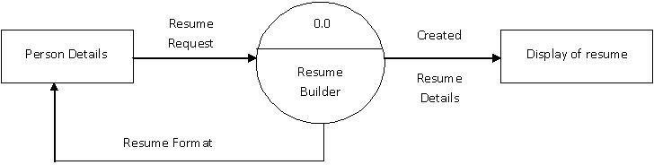

1. **level DFD:**

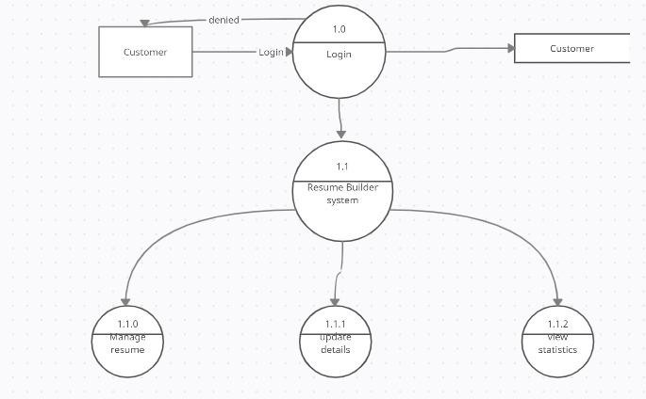

**Use case Diagram:**

Use Case Model is an approach that is a combination of text and pictures to improve the understanding of requirements. A use case model' is describing the complete functionality of a system by identifying how everything that is outside the system interacts with it.

A Use Case Diagram is given below that relates to this application.

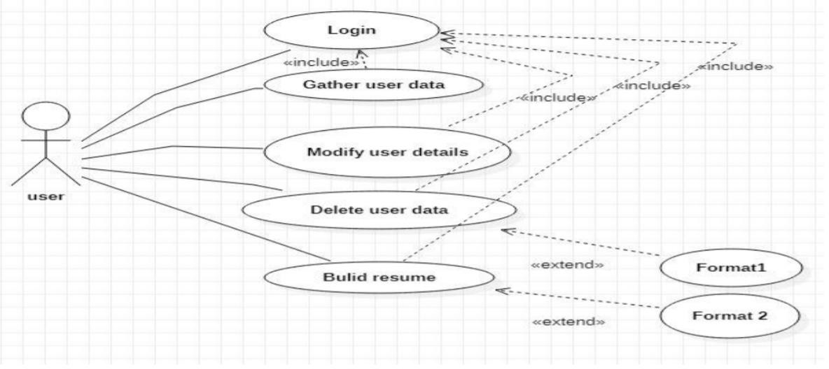

# System Design

System design is a solution, a ‘how to’ approach to the creation of a new system. It provides the understanding and procedural details necessary for implementing the system recommended in the feasibility study. Emphasis is on translating the performance requirements into design specifications.

Design goes through logical and physical stages of development. Logical design reviews the present physical system; prepared input and output specifications; details the implementation plan; and prepares a logical design walkthrough. The physical design maps out the details of the physical system, plans the system implementation, devises a test and implementation plan, and specifies any new hardware and software.

# Database Tables

#### Admin Table

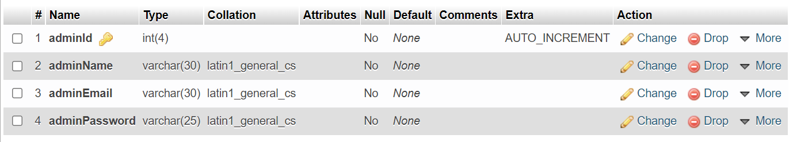

**Employee Table**

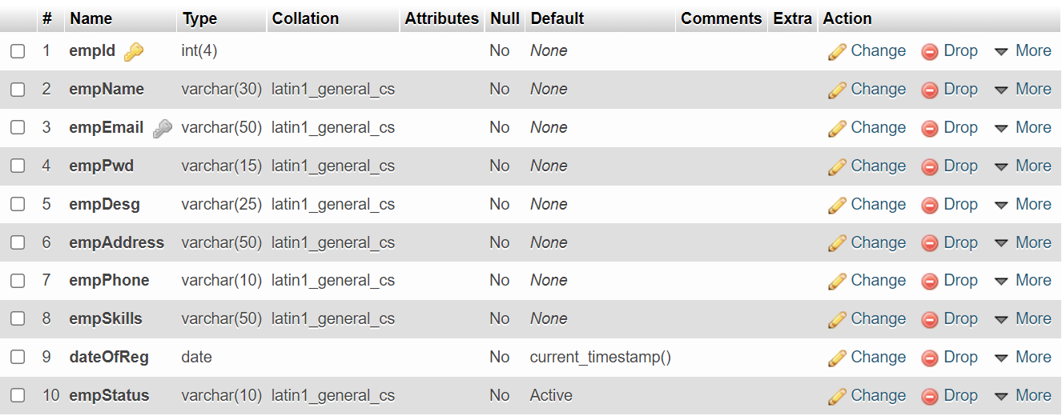

**Project Table**

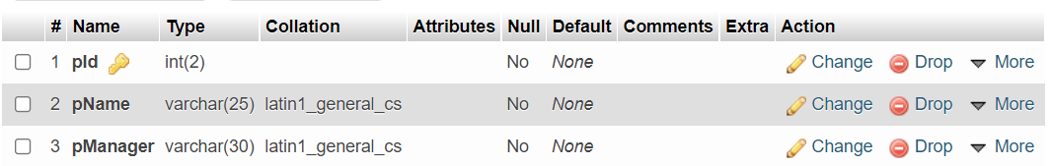

**ProjectDetails Details**

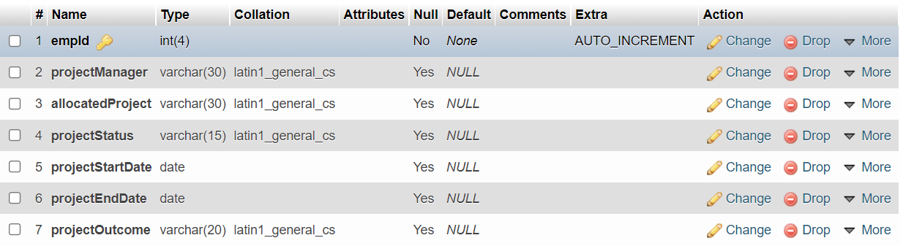

**UpdateDetails Table**

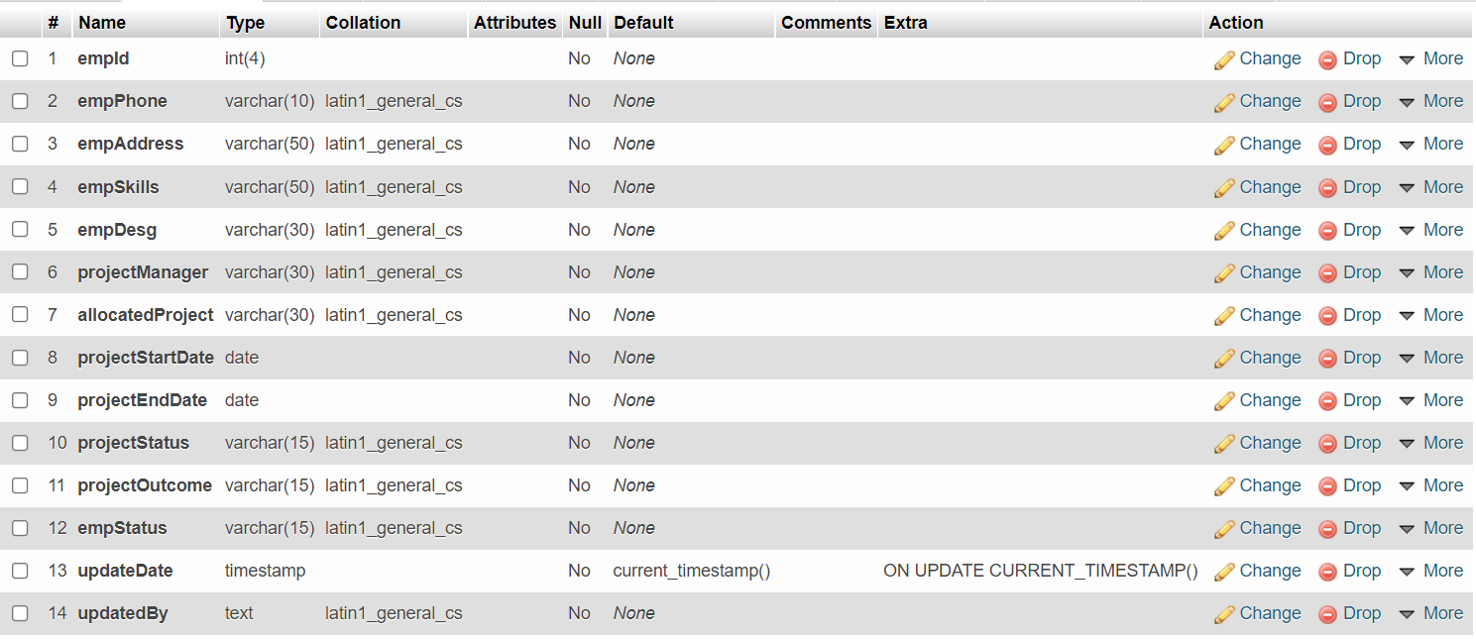

# 5 Implementation

## Code:

**Login Panel :-**

<!DOCTYPE html>

<html lang="en">

<head>

<title>OFFICE COLLABORATOR</title>

<meta charset="UTF-8" content="shrink-to-fit=no">

<meta http-equiv="X-UA-Compatible" content="IE=edge">

<meta name="viewport" content="width=device-width, initial-scale=1.0">

<link rel="stylesheet" href="https://pro.fontawesome.com/releases/v5.10.0/css/all.css" integrity="sha384-AYmEC3Yw5cVb3ZcuHtOA93w35dYTsvhLPVnYs9eStHfGJvOvKxVfELGroGkvsg+p" crossorigin="anonymous"/>

<link rel="stylesheet" type="text/css" href="style.css">

</head>

<body>

<br><h2 style="font-size:25px;font-family:Verdana;margin-left: 34%;">OFFICE COLLABORATOR</h2>

<br>

<div class="login-form" style="margin:auto;">

<h2>LOGIN PANEL</h2>

<form method="POST">

<div class="input-field">

<i class="fas fa-user"></i>

<input type="text" placeholder="Email" name="AdminEmail">

</div>

<div class="input-field">

<i class="fas fa-lock"></i>

<input type="password" placeholder="Password" name="AdminPassword">

</div>

<button type="submit" name="signin">LOGIN</button>

</form>

</div>

</body>

</html>

<?php

require("conn.php");

?>

<?php

if(isset($_POST['signin']))

{

$query="SELECT * FROM `ocdb`.`admin` WHERE `adminEmail` ='$_POST[AdminEmail]' AND `adminPassword`='$_POST[AdminPassword]'";

$result=mysqli_query($con,$query);

//echo (mysqli_num_rows($result));

if(mysqli_num_rows($result)==1)

{

session_start();

$row=mysqli_fetch_assoc($result);

$_SESSION['AdminLoginId']=$row['adminName'];

header("location: Admin Panel.php");

//echo "correct";

}

else

{

echo"<script>alert('Incorrect password');</script>";

//echo "incorrect";

}

}

if(isset($_POST['signin']))

{

//$userStatus = "Active";

$query="SELECT * FROM `ocdb`.`empdetail` WHERE `empEmail` ='$_POST[AdminEmail]' AND `empPwd`='$_POST[AdminPassword]' ";

$result=mysqli_query($con,$query);

// $row1=mysqli_fetch_assoc($result);

// $empStatus = $row1['empStatus'];

// //echo (mysqli_num_rows($result));

// $cmpResult=strcmp($userStatus,$empStatus);

// if($cmpResult==0){

// }

// else{

// echo"<script>alert('User is Not Active');</script>";

// }

if(mysqli_num_rows($result)==1)

{

session_start();

$row=mysqli_fetch_assoc($result);

$_SESSION['AdminLoginId']=$row['empEmail'];

header("location: Employee Dashboard.php");

//echo "correct";

}

else

{

echo"<script>alert('Incorrect password');</script>";

//echo "incorrect";

}

}

?>

**Admin Dashboard**:-

<?php

session_start();

if(!isset($_SESSION['AdminLoginId']))

{

header("Location: login panel.php");

}

?>

<?php

require_once("conn.php");

$query = " select * from `ocdb`.`empdetail` ";

$result = mysqli_query($con,$query);

?>

<!DOCTYPE html>

<html lang="en">

<head>

<meta charset="UTF-8">

<meta http-equiv="X-UA-Compatible" content="IE=edge">

<meta name="viewport" content="width=device-width, initial-scale=1.0">

<title>ADMIN PANEL</title>

<link rel="stylesheet" a href="CSS/bootstrap.css"/>

<link rel="stylesheet" href="https://pro.fontawesome.com/releases/v5.10.0/css/all.css" integrity="sha384-AYmEC3Yw5cVb3ZcuHtOA93w35dYTsvhLPVnYs9eStHfGJvOvKxVfELGroGkvsg+p" crossorigin="anonymous"/>

<style>

body {

margin: 0px;

}

div.header{

display:flex;

font-family:poppins;

justify-content:space-between;

align-items:center;

padding: 15px 60px;

background-color: darkseagreen;

}

div.header button{

background-color: revert;

font-size: 16px;

font-weight: 550;

padding: 14px 22px;

border: 2px solid black;

border-radius: 5px;

}

div.div.but{

align-items: center;

margin-left: 25%;

padding:250px;

}

div.but button{

padding:30px;

align-items: center;

width:150px;

height:50px;

border: 2px solid black;

border-radius: 5px;

background-color: #ff6d6d;

/* font-size: 16px;

font-weight: 550;

padding: 8px 12px;

border: 2px solid black;

border-radius: 5px; */

}

</style>

</head>

<body>

<div class="header">

<h1 style="font-size:32px;">Admin Dashboard - <?php echo $_SESSION['AdminLoginId']?></h1>

<form method="POST" action="empregform.php">

<button name="update" style="margin-left:400px;" ><i class="fas fa-user-edit"></i> ADD</button>

</form>

<form method="POST" action="adminsearch.php">

<button name="update" ><i class="fas fa-search"></i> SEARCH</button>

</form>

<form method="POST" >

<button name="logout"><i class="fas fa-sign-out-alt"></i> LOGOUT</button>

</form>

</div>

<div>

<h2 style="font-size:22px;margin-top: 7px;text-align: center;

margin-bottom: -29px;"><u>All Employee Details</u></h2>

</div>

<div class="container">

<div class="row">

<div class="col m-auto">

<div class="card mt-5">

<table class="table table-bordered">

<tr style="background-color:lightgreen;border: 2px solid black;">

<td> EmpId </td>

<td> Employee Name </td>

<td> Email </td>

<td> Designation </td>

<!-- <td> Address </td> -->

<td> Phone No </td>

<td> Employee Status </td>

<td> </td>

</tr>

<?php

// display number total employees

while($row=mysqli_fetch_assoc($result))

{

$userId = $row['empId'];

$userName = $row['empName'];

$userEmail = $row['empEmail'];

$userDesg = $row['empDesg'];

$empStatus = $row['empStatus'];

$userPhone = $row['empPhone'];

?>

<tr>

<td><?php echo $userId ?></td>

<td><?php echo $userName ?></td>

<td><?php echo $userEmail ?></td>

<td><?php echo $userDesg ?></td>

<!-- <td><?php echo $userAddress ?></td> -->

<td><?php echo $userPhone ?></td>

<td><?php echo $empStatus ?></td>

<td><a href="empfulldetail.php?GetEmail=<?php echo $userEmail ?>">See details</a></td>

<!-- <td><a href="delete.php?Del=<?php echo $userEmail ?>">Delete</a></td> -->

</tr>

<?php

}

?>

</table>

</div>

</div>

</div>

</div>

<br>

<?php

if(isset($_POST['logout']))

{

session_destroy();

echo"<script>window.location.href=window.location.origin+'/project/login%20panel.php';</script>";

}

else if(isset($_POST['add']))

{

header("Location: empaddingquery.php");

}

?>

</body>

</html>

**Employee Registration Form:-**

<?php

session_start();

if(!isset($_SESSION['AdminLoginId']))

{

header("Location: login panel.php");

}

?>

<!DOCTYPE html>

<html lang="en">

<head>

<style>

div.header{

display:flex;

font-family:poppins;

justify-content:space-between;

align-items:center;

padding: 18px 60px;

background-color: darkseagreen;

}

div.header button{

background-color: revert;

font-size: 16px;

font-weight: 550;

padding: 14px 22px;

border: 2px solid black;

border-radius: 5px;

}

</style>

<meta charset="UTF-8">

<meta name="viewport" content="width=device-width, initial-scale=1.0">

<meta http-equiv="X-UA-Compatible" content="ie=edge">

<link rel="stylesheet" href="https://cdnjs.cloudflare.com/ajax/libs/font-awesome/5.13.0/css/all.min.css">

<link rel="stylesheet" a href="CSS/bootstrap.css"/>

<title>Employee Registration Form</title>

</head>

<body class="bg-white">

<div class="header">

<h1 style="font-size:32px;">Admin Dashboard - <?php echo $_SESSION['AdminLoginId']?></h1>

<!-- <form method="POST" action="empview.php">

<button name="view" ><i class="fas fa-user-plus"></i> VIEW COMPANIANS</button>

</form> -->

<form method="POST" action="login panel.php">

<button name="logout">LOGOUT</button>

</form>

</div>

<div class="container">

<div class="row">

<div class="col-lg-6 m-auto">

<div class="card mt-5">

<div class="card-title">

<h3 class="bg-secondary text-white text-center py-3">Employee Registration Form </h3>

</div>

<div class="card-body">

<form action="empaddingquery.php" method="post" name="myform">

<input type="text" class="form-control mb-2" placeholder=" Employee Name " name="name" required>

<input type="email" onblur="return validateemail();" class="form-control mb-2" placeholder=" Employee Email " name="email" required>

<input type="password" class="form-control mb-2" placeholder=" Password "id="myInput" name="password" required>

<input type="checkbox" onclick="myFunction()" style="margin-left:10px;margin-bottom:10px;"> Show Password

<input type="text" class="form-control mb-2" placeholder=" Designation " name="desg" required>

<input type="text" class="form-control mb-2" placeholder=" Address " name="address" required>

<input type="text" onblur="return validatePhoneNo()" class="form-control mb-2" placeholder=" Phone No " name="phoneno" required><span id="numloc"></span>

<input type="text" class="form-control mb-2" placeholder=" Skills " name="skills" autocomplete="off" required>

<button class="btn btn-primary" onclick="return CheckPassword();" name="submit">Submit</button>

</form>

<form action="Admin Panel.php" method="post">

<button style="margin-top: -67px;margin-left: 90px"

class="btn btn-primary" name="back">Back</button>

</form>

</div>

</div>

</div>

</div>

</div>

<script>

function myFunction() {

var x = document.getElementById("myInput");

if (x.type === "password") {

x.type = "text";

} else {

x.type = "password";

}

}

</script>

<script>

function validatePhoneNo()

{

var num=document.myform.phoneno.value;

if (isNaN(num))

{

alert("Phone No. must be numeric only");

return false;

}

if(num.length>10 || num.length<10)

{

alert("Phone No. must be of 10 characters");

return false;

}

if(num.charAt(0)<='5'){

alert("Phone no. must start with 6 and greater values");

return false;

}

}

</script>

<script>

function validateemail()

{

var x=document.myform.email.value;

var atposition=x.indexOf("@");

var dotposition=x.lastIndexOf(".");

if (atposition<1 || dotposition<atposition+2 || dotposition+2>=x.length){

alert("Please enter a valid e-mail address");

return false;

}

}

</script>

<script>

function CheckPassword()

{

var text=document.myform.password.value;

if(text.length<8 ||text.length>15)

{

alert("Password length must be of 8 to 15 char long");

return false;

}

//console.log(text);

// var capCount=0,lowCount=0,speCount=0,numCount=0,speCountType2=0;

// if(text.lenght>8 && text.length<15)

// {

// for(var i=0;i<text.length;i++)

// {console.log(text.charAt(i));

// if(text.chatAt(i)>64 && text.chatAt(i)<91)

// {capCount=1;}

// else if(text.chatAt(i)>96 && text.chatAt(i)<123)

// {lowCount=1;}

// else if(text.chatAt(i)>32 && text.chatAt(i)<48)

// {speCount=1;}

// else if(text.chatAt(i)>57 && text.chatAt(i)<65)

// {speCountType2=1;}

// else if(text.chatAt(i)>47 && text.chatAt(i)<58)

// {numCount=1;}

// }

// if(speCountType2==0 || speCount=0)

// { alert("password must contain a special character");

// return false;

// }

// if(capCount==0 && lowCount==0 )

// {

// alert("password must contain a upper case and a lower case character");

// return false;

// }

// if(numCount==0)

// {

// alert("password must contain a number");

// return false;

// }

// }

// else{

// alert("password length must be 8 t0 15 character long");

// return false;

// }

}

</script>

</body>

</html>

<?php

if(isset($_POST['logout']))

{

session_destroy();

echo"<script>window.location.href=window.location.origin+'/project/login%20panel.php';</script>";

}

?>

**Search Employee:-**

<?php

session_start();

if(!isset($_SESSION['AdminLoginId']))

{

header("Location: login panel.php");

}

?>

<?php

error_reporting(0);

require_once("conn.php");

if(isset($_POST['search']))

{

$str=mysqli_real_escape_string($con,$_POST['str']);

$sql="select * from empdetail where empEmail='$str' OR empPhone='$str' OR empId='$str' OR empStatus='$str' ";

$result=mysqli_query($con,$sql);

if(mysqli_num_rows($result)==0)

{

echo"<script>alert('Data Not Found');</script>";

//return false;

}

}

?>

<!DOCTYPE html>

<html lang="en">

<head>

<style>

div.header{

display:flex;

font-family:poppins;

justify-content:space-between;

align-items:center;

padding: 15px 60px;

background-color: darkseagreen;

}

div.header button{

background-color: revert;

font-size: 16px;

font-weight: 550;

padding: 14px 22px;

border: 2px solid black;

border-radius: 5px;

}

</style>

<meta charset="UTF-8">

<meta http-equiv="X-UA-Compatible" content="IE=edge">

<meta name="viewport" content="width=device-width, initial-scale=1.0">

<link rel="stylesheet" href="https://pro.fontawesome.com/releases/v5.10.0/css/all.css" integrity="sha384-AYmEC3Yw5cVb3ZcuHtOA93w35dYTsvhLPVnYs9eStHfGJvOvKxVfELGroGkvsg+p" crossorigin="anonymous"/>

<link rel="stylesheet" a href="CSS/bootstrap.css"/>

<title>Search</title>

</head>

<body>

<div class="header">

<h1 style="font-size:32px;">Admin Dashboard - <?php echo $_SESSION['AdminLoginId']?></h1>

<form method="POST" action="Admin Panel.php">

<button style="margin-left:500px;background-color:#e9e9e9;" name="update" ><i class="fas fa-backward"></i> BACK</button>

</form>

<form method="POST" action="login panel.php">

<button name="logout"><i class="fas fa-sign-out-alt"></i> LOGOUT</button>

</form>

</div>

<h2 style="font-size: 1.5rem;text-align: center;"><u>Find Employee by their Details</u></h2>

<form method="POST">

<div class="srch" style="text-align: center;">

<form autocomplete="off">

<label style="padding: 10px;font-size: 20px;font-weight: 600;">Search by - </label>

<select name="str1" id="pstatus">

<option value="empEmail">Email</option>

<option value="empStatus">Employee Status</option>

<option value="empId">Employee ID</option>

<option value="empPhone">Phone No</option>

</select>

<b> : </b><input type="textbox" name="str" required/>

<input type="submit" name="search" value="SEARCH" />

</form>

</div>

</form>

<div class="container">

<div class="row">

<div class="col m-auto">

<div class="card mt-5">

<table class="table table-bordered">

<tr style="background-color:lightgreen;border: 2px solid black;">

<th> EmpId </th>

<th> Employee Name </th>

<th> Email </th>

<th> Designation </th>

<!-- <th> Address </th> -->

<th> Phone No </th>

<th> </th>

</tr>

<?php

// display number total employees

while($row=mysqli_fetch_assoc($result))

{

$userId = $row['empId'];

$userName = $row['empName'];

$userEmail = $row['empEmail'];

$userDesg = $row['empDesg'];

// $userAddress = $row['empAddress'];

$userPhone = $row['empPhone'];

?>

<tr>

<td><?php echo $userId ?></td>

<td><?php echo $userName ?></td>

<td><?php echo $userEmail ?></td>

<td><?php echo $userDesg ?></td>

<!-- <td><?php echo $userAddress ?></td> -->

<td><?php echo $userPhone ?></td>

<td><a href="empfulldetail.php?GetEmail=<?php echo $userEmail ?>">See details</a></td>

<!-- <td><a href="delete.php?Del=<?php echo $userEmail ?>">Delete</a></td> -->

</tr>

<?php

}

?>

</table>

</div>

</div>

</div>

</div>

<!-- <form action="Admin Panel.php" >

<div style=" margin-left: 50%;

margin-top: 2%;"><button class="btn btn-primary" name="back">BACK</button></div>

</form> -->

<!-- <?php

if(isset($_POST['logout']))

{

session_destroy();

echo"<script>window.location.href=window.location.origin+'/project/login%20panel.php';</script>";

// header("Location:login panel.php");

}

?> -->

</body>

</html>

**Employee Adding Query:-**

<?php

require_once("conn.php");

if(isset($_POST['submit']))

{

if(empty($_POST['name']) || empty($_POST['email']) || empty($_POST['password']) || empty($_POST['desg']) || empty($_POST['address']) || empty($_POST['phoneno']) || empty($_POST['skills']))

{

echo"<script>alert('All fields are mandatory.');</script>";

}

else{

$userName=$_POST['name'];

$userEmail=$_POST['email'];

$userPassword=$_POST['password'];

$userDesg=$_POST['desg'];

$userAddress=$_POST['address'];

$userPhoneNo=$_POST['phoneno'];

$userSkills=$_POST['skills'];

$query3 = " select * from empdetail";

$result3 = mysqli_query($con,$query3);

$row=mysqli_num_rows($result3);

$empId=$row+1;

//echo "there are".$empId."rows";

$query1 = " insert into empdetail (empId,empName,empEmail,empPwd,empDesg,empAddress,empPhone,empSkills)

values('$empId','$userName','$userEmail','$userPassword','$userDesg','$userAddress','$userPhoneNo','$userSkills')";

$result = mysqli_query($con,$query1);

$query2 ="insert into projectdetails (empId,projectManager) values('$empId','NULL')";

mysqli_query($con,$query2);

$query4 ="insert into updatedetail (empId,empDesg,updatedBy) values('$empId','$userDesg','A')";

mysqli_query($con,$query4);

if($result)

{

header("location:Admin Panel.php");

}

else

{

echo"<script>alert('Please check your Query');</script>";

}

}

}

// else if(isset($_POST['back']))

// {

// header("location:Admin Panel.php");

// }

else

{

header("location:index1.php");

}

?>

**Employee Full Details:-**

<?php

session_start();

if(!isset($_SESSION['AdminLoginId']))

{

header("Location: login panel.php");

}

?>

<?php

require_once("conn.php");

$userEmail = $_GET['GetEmail'];

$query = " select * from empdetail INNER JOIN projectdetails ON empdetail.empId = projectdetails.empId where empEmail='".$userEmail."' ";

//$query = ' select * from empdetail where email="'.$userEmail.'" ';

$result = mysqli_query($con,$query);

//echo("<script>console.log('PHP :".$result."');</script>");

?>

<!DOCTYPE html>

<html lang="en">

<head>

<meta charset="UTF-8">

<meta http-equiv="X-UA-Compatible" content="IE=edge">

<meta name="viewport" content="width=device-width, initial-scale=1.0">

<title>ADMIN PANEL</title>

<link rel="stylesheet" a href="CSS/bootstrap.css"/>

<link rel="stylesheet" href="https://pro.fontawesome.com/releases/v5.10.0/css/all.css" integrity="sha384-AYmEC3Yw5cVb3ZcuHtOA93w35dYTsvhLPVnYs9eStHfGJvOvKxVfELGroGkvsg+p" crossorigin="anonymous"/>

<style>

body {

margin: 0px;

}

div.header{

display:flex;

font-family:poppins;

justify-content:space-between;

align-items:center;

padding: 15px 60px;

background-color: darkseagreen;

}

div.header button{

background-color: revert;

font-size: 16px;

font-weight: 550;

padding: 14px 22px;

border: 2px solid black;

border-radius: 5px;

}

div.div.but{

align-items: center;

margin-left: 25%;

padding:250px;

}

div.but button{

padding:30px;

align-items: center;

width:150px;

height:50px;

border: 2px solid black;

border-radius: 5px;

background-color: #ff6d6d;

/* font-size: 16px;

font-weight: 550;

padding: 8px 12px;

border: 2px solid black;

border-radius: 5px; */

}

</style>

</head>

<body>

<div class="header">

<h1 style="font-size:32px;">Admin Dashboard - <?php echo $_SESSION['AdminLoginId']?></h1>

<form method="POST" action="Admin Panel.php">

<button style="margin-left:500px;background-color:#e9e9e9;" name="update" ><i class="fas fa-backward"></i> BACK</button>

</form>

<form method="POST" >

<button name="logout"><i class="fas fa-sign-out-alt"></i> LOGOUT</button>

</form>

</div>

<div>

<h2 style="font-size:22px;text-align: center;margin-top: 7px;

margin-bottom: -29px;">Employee Full Detail</h2>

</div>

<div class="container">

<div class="row">

<div class="col m-auto">

<div class="card mt-5">

<table class="table table-bordered">

<tr style="background-color:lightgreen">

<td> EmpId </td>

<td> Employee Name </td>

<td> Email </td>

<td> Designation </td>

<td> Address </td>

<td> Phone No </td>

<td> Skills </td>

<td> Date of Reg </td>

</tr>

<?php

while($row=mysqli_fetch_assoc($result))

{

$userId = $row['empId'];

$userName = $row['empName'];

$userEmail = $row['empEmail'];

$userDesg = $row['empDesg'];

$userAddress = $row['empAddress'];

$userPhone = $row['empPhone'];

$userSkills = $row['empSkills'];

$userDoj = $row['dateOfReg'];

$userStatus = $row['empStatus'];

$userPmanager= $row['projectManager'];

$allocatedProject = $row['allocatedProject'];

$projectStartDate = $row['projectStartDate'];

$projectEndDate = $row['projectEndDate'];

$projectStatus = $row['projectStatus'];

$projectOutcome = $row['projectOutcome'];

?>

<tr>

<td><?php echo $userId ?></td>

<td><?php echo $userName ?></td>

<td><?php echo $userEmail ?></td>

<td><?php echo $userDesg ?></td>

<td><?php echo $userAddress ?></td>

<td><?php echo $userPhone ?></td>

<td><?php echo $userSkills ?></td>

<td><?php echo $userDoj ?></td>

<!-- <td><a href="edit.php?GetEmail=<?php echo $userEmail ?>">Update</a></td> -->

<!-- <td><a href="delete.php?Del=<?php echo $userEmail ?>">Delete</a></td> -->

</tr>

<tr style="background-color:lightgreen">

<td> Project Manager </td>

<td> Allocated Project </td>

<td> Project Start Date </td>

<td> Project End Date </td>

<td> Project Status </td>

<td> Project Outcome </td>

<td> Employee Status </td>

<td> </td>

</tr>

<tr>

<td><?php echo $userPmanager ?></td>

<td><?php echo $allocatedProject ?></td>

<td><?php echo $projectStartDate ?></td>

<td><?php echo $projectEndDate ?></td>

<td><?php echo $projectStatus ?></td>

<td><?php echo $projectOutcome ?></td>

<td><?php echo $userStatus ?></td>

<td><a href="edit.php?GetEmail=<?php echo $userEmail ?>">Update</a></br><a href="previousdata.php?GetID=<?php echo $userId ?>">PreviousData</a></td>

</tr>

<?php

}

?>

</table>

</div>

</div>

</div>

</div>

<br>

<?php

if(isset($_POST['logout']))

{

session_destroy();

echo"<script>window.location.href=window.location.origin+'/project/login%20panel.php';</script>";

}

else if(isset($_POST['add']))

{

header("Location: empaddingquery.php");

}

?>

</body>

</html>

**Employee Update:-**

<?php

session_start();

if(!isset($_SESSION['AdminLoginId']))

{

header("Location: login panel.php");

}

?>

<?php

require_once("conn.php");

$userEmail = $_GET['GetEmail'];

$query = " select * from empdetail INNER JOIN projectdetails ON empdetail.empId = projectdetails.empId where empEmail='".$userEmail."' ";

$result = mysqli_query($con,$query);

while($row=mysqli_fetch_assoc($result))

{

$userDesg = $row['empDesg'];

$userPmanager = $row['projectManager'];

$allocatedproject = $row['allocatedProject'];

$projectStartDate = $row['projectStartDate'];

$projectEndDate = $row['projectEndDate'];

$projectStatus = $row['projectStatus'];

$projectOutcome = $row['projectOutcome'];

$userStatus = $row['empStatus'];

}

?>

<!DOCTYPE html>

<html lang="en">

<head>

<style>

body {

margin: 0px;

}

div.header{

display:flex;

font-family:poppins;

justify-content:space-between;

align-items:center;

padding: 15px 60px;

background-color: darkseagreen;

}

div.header button{

background-color: revert;

font-size: 16px;

font-weight: 550;

padding: 14px 22px;

border: 2px solid black;

border-radius: 5px;

}

div.div.but{

align-items: center;

margin-left: 25%;

padding:250px;

}

div.but button{

padding:30px;

align-items: center;

width:150px;

height:50px;

border: 2px solid black;

border-radius: 5px;

background-color: #ff6d6d;

/* font-size: 16px;

font-weight: 550;

padding: 8px 12px;

border: 2px solid black;

border-radius: 5px; */

}

</style>

<meta charset="UTF-8">

<meta name="viewport" content="width=device-width, initial-scale=1.0">

<meta http-equiv="X-UA-Compatible" content="ie=edge">

<link rel="stylesheet" a href="CSS/bootstrap.css"/>

<title>Employee Updation Form</title>

</head>

<body class="bg-white">

<div class="header">

<!-- <script>

console.log($result);

</script> -->

<h1 style="font-size:32px;">Admin : <?php echo $_SESSION['AdminLoginId']?></h1>

<!-- logout button -->

<form method="POST" action="login panel.php">

<button name="logout"><i class="fas fa-sign-out-alt"></i> LOGOUT</button>

</form>

</div>

<div class="container">

<div class="row">

<div class="col-lg-6 m-auto">

<div class="card mt-5">

<div class="card-title">

<h3 class="bg-secondary text-white text-center py-3"> Update Employee Details Here </h3>

</div>

<div class="card-body">

<!-- Fields which employee can edit -->

<form action="update.php?GetEmail=<?php echo $userEmail ?>" method="post">

<label style="padding: 10px;font-size: 20px;font-weight: 600;">Desigination</label>

<input type="text" class="form-control mb-2" name="desg" value="<?php echo $userDesg ?>">

<!-- <label style="padding: 10px;font-size: 20px;font-weight: 600;">Phone No</label>

<input type="text" class="form-control mb-2" placeholder=" Phone Number " name="phoneno" value="<?php echo $userPhone ?>">

<label style="padding: 10px;font-size: 20px;font-weight: 600;">Skills</label>

<input type="text" class="form-control mb-2" name="skills" value="<?php echo $userSkills ?>"> -->

<!-- <label style="padding: 10px;font-size: 20px;font-weight: 600;">Project Manager</label>

<input type="text" class="form-control mb-2" name="pManager" value="<?php echo $userPmanager ?>"> -->

<label style="padding: 10px;font-size: 20px;font-weight: 600;">Allocated Project</label>

<!-- <input type="text" class="form-control mb-2" name="pAllocated" value="<?php echo $allocatedproject ?>"> -->

<select name="pAllocated" id="pallo">

<option value="1">Office Collaborator</option>

<option value="2">Mobile App</option>

<option value="3">Shopping Site</option>

</select>

</br>

<label style="padding: 10px;font-size: 20px;font-weight: 600;">Allocated Project Start Date</label>

<input type="date" class="form-control mb-2" name="pStart" value="<?php echo $projectStartDate ?>">

<label style="padding: 10px;font-size: 20px;font-weight: 600;">Allocated Project End Date</label>

<input type="date" class="form-control mb-2" name="pEnd" value="<?php echo $projectEndDate ?>">

<label style="padding: 10px;font-size: 20px;font-weight: 600;">Project Status : </label>

<!-- <input type="text" class="form-control mb-2" name="skills" value="<?php echo $projectStatus ?>"> -->

<select name="projectstatus" id="pstatus">

<option value="Ongoing">Ongoing</option>

<option value="Complete">Complete</option>

<option value="Failed">Failed</option>

</select>

</br>

<label style="padding: 10px;font-size: 20px;font-weight: 600;">Project Outcome : </label>

<!-- <input type="text" class="form-control mb-2" name="skills" value="<?php echo $projectOutcome ?>"> -->

<select name="projectoutcome" id="poutcome">

<option value="Deleivered">Deleivered</option>

<option value="Not Deleivered">Not Deleivered</option>

<option value="Failed">Failed</option>

</select>

</br>

<label style="padding: 10px;font-size: 20px;font-weight: 600;">Employee Status : </label>

<!-- <input type="text" class="form-control mb-2" name="skills" value="<?php echo $userStatus ?>"> -->

<select name="empstatus" id="estatus">

<option value="Active">Active</option>

<option value="Not Active">Not Active</option>

</select>

</br>

<button class="btn btn-primary" name="update">Update</button>

<button class="btn btn-primary" name="back">BACK</button>

</form>

</div>

</div>

</div>

</div>

</div>

<?php

if(isset($_POST['logout']))

{

session_destroy();

echo"<script>window.location.href=window.location.origin+'/project/login%20panel.php';</script>";

}

else if(isset($_POST['add']))

{

header("Location: empaddingquery.php");

}

?>

</body>

</html>

**Employee update query:-**

<?php

require_once("conn.php");

if(isset($_POST['update']))

{

$userEmail = $_GET['GetEmail'];

$query2="select empId from empdetail where empEmail='".$userEmail."' ";

$result2=mysqli_query($con,$query2);

// echo $result2;

$row=mysqli_fetch_assoc($result2);

$userId = $row['empId'];

//echo "my id is : " .$userId.

$userDesg = $_POST['desg'];

$projectManager = $_POST['pManager'];

$projectAllocated = $_POST['pAllocated'];

$projectStart = $_POST['pStart'];

$projectEnd = $_POST['pEnd'];

$projectStatus = $_POST['projectstatus'];

$projectOutcome = $_POST['projectoutcome'];

$empStatus = $_POST['empstatus'];

$query5="select pName,pManager from project where pId='".$projectAllocated."' ";

$result5=mysqli_query($con,$query5);

// echo $result2;

$row=mysqli_fetch_assoc($result5);

$pName = $row['pName'];

$pManager = $row['pManager'];

$query1 = " update empdetail set empDesg = '".$userDesg."',empStatus='".$empStatus."' where empEmail='".$userEmail."' ";

mysqli_query($con,$query1);

$query4 ="insert into updatedetail (empId,empDesg,projectManager,allocatedProject,projectStartDate,projectEndDate,projectStatus,projectOutcome,empStatus,updatedBy) values('$userId','$userDesg','$projectManager','$projectAllocated','$projectStart','$projectEnd','$projectStatus','$projectOutcome','$empStatus','A')";

mysqli_query($con,$query4);

$query = " update projectdetails set projectManager = '".$pManager."',allocatedProject='".$pName."',

projectStartDate='".$projectStart."',projectEndDate='".$projectEnd."',projectOutcome='".$projectOutcome."',

projectStatus='".$projectStatus."' where empId='".$userId."'";

$result = mysqli_query($con,$query);

if($result)

{

header("location:Admin Panel.php");

}

else

{

echo"<script>alert('Please check your Query');</script>";

}

}

else if(isset($_POST['back']))

{

header("location:Admin Panel.php");

}

else

{

header("location:view.php");

}

?>

**Employee previous records:-**

<?php

session_start();

if(!isset($_SESSION['AdminLoginId']))

{

header("Location: login panel.php");

}

?>

<?php

require_once("conn.php");

$userId = $_GET['GetID'];

$query2 = " select empName from `ocdb`.`empdetail` where empId='".$userId."' ";

$result2=mysqli_query($con,$query2);

$row=mysqli_fetch_assoc($result2);

$userName = $row['empName'];

$query = " select * from `ocdb`.`updatedetail` where empId='".$userId."' order by updateDate desc ";

$result = mysqli_query($con,$query);

?>

<!DOCTYPE html>

<html lang="en">

<head>

<meta charset="UTF-8">

<meta http-equiv="X-UA-Compatible" content="IE=edge">

<meta name="viewport" content="width=device-width, initial-scale=1.0">

<title>ADMIN PANEL</title>

<link rel="stylesheet" a href="CSS/bootstrap.css"/>

<link rel="stylesheet" href="https://pro.fontawesome.com/releases/v5.10.0/css/all.css" integrity="sha384-AYmEC3Yw5cVb3ZcuHtOA93w35dYTsvhLPVnYs9eStHfGJvOvKxVfELGroGkvsg+p" crossorigin="anonymous"/>

<style>

body {

margin: 0px;

}

div.header{

display:flex;

font-family:poppins;

justify-content:space-between;

align-items:center;

padding: 15px 60px;

background-color: darkseagreen;

}

div.header button{

background-color: revert;

font-size: 16px;

font-weight: 550;

padding: 14px 22px;

border: 2px solid black;

border-radius: 5px;

}

div.div.but{

align-items: center;

margin-left: 25%;

padding:250px;

}

div.but button{

padding:30px;

align-items: center;

width:150px;

height:50px;

border: 2px solid black;

border-radius: 5px;

background-color: #ff6d6d;

/* font-size: 16px;

font-weight: 550;

padding: 8px 12px;

border: 2px solid black;

border-radius: 5px; */

}

</style>

</head>

<body>

<div class="header">

<h1 style="font-size:32px;">Admin Dashboard - <?php echo $_SESSION['AdminLoginId']?></h1>

<form method="POST" action="Admin Panel.php">

<button style="margin-left:500px;background-color:#e9e9e9;" name="update" ><i class="fas fa-backward"></i> BACK</button>

</form>

<form method="POST" >

<button name="logout"><i class="fas fa-sign-out-alt"></i> LOGOUT</button>

</form>

</div>

<div>

<h1 style="font-size:30px;margin-top: 7px;text-align: center;

margin-bottom: -29px;"><u>Previous Updated Details of Employee</u></h1></br></br>

<h2 style="font-size:22px;margin-top: 7px;text-align: center;

margin-bottom: -29px;"><u>Employee ID</u> : <?php echo $userId?>&nbsp;&nbsp;&nbsp;&nbsp;&nbsp;&nbsp;&nbsp;&nbsp;&nbsp;&nbsp;&nbsp;<u>Employee Name</u> : <?php echo $userName?></h2>

</div>

<div class="container">

<div class="row">

<div class="col m-auto">

<div class="card mt-5">

<table class="table table-bordered">

<tr style="background-color:lightgreen;border: 2px solid black;">

<th> Employee Designation </th>

<th> Skills </th>

<th> Project Manager </th>

<th> Allocated Project </th>

<th> Project Start Date </th>

<th> Project End Date </th>

<th> Project Status </th>

<th> Project Outcome </th>

<th> Employee Status </th>

<th> Update Date </th>

<th> Update BY </th>

</tr>

<?php

// display number total employees

while($row=mysqli_fetch_assoc($result))

{

$userDesg = $row['empDesg'];

$projectManager = $row['projectManager'];

$skills=$row['empSkills'];

$allocatedProject = $row['allocatedProject'];

$projectStartDate = $row['projectStartDate'];

$projectEndDate = $row['projectEndDate'];

$projectStatus = $row['projectStatus'];

$projectOutcome = $row['projectOutcome'];

$empStatus = $row['empStatus'];

$updateDate = $row['updateDate'];

$updatedBy = $row['updatedBy'];

?>

<tr>

<td><?php echo $userDesg ?></td>

<td><?php echo $skills ?></td>

<td><?php echo $projectManager ?></td>

<td><?php echo $allocatedProject ?></td>

<td><?php echo $projectStartDate ?></td>

<td><?php echo $projectEndDate ?></td>

<td><?php echo $projectStatus ?></td>

<td><?php echo $projectOutcome ?></td>

<td><?php echo $empStatus ?></td>

<td><?php echo $updateDate ?></td>

<td><?php echo $updatedBy ?></td>

<!-- <td><a href="empfulldetail.php?GetEmail=<?php echo $userEmail ?>">See details</a></td> -->

<!-- <td><a href="delete.php?Del=<?php echo $userEmail ?>">Delete</a></td> -->

</tr>

<?php

}

?>

</table>

</div>

</div>

</div>

</div>

<br>

<?php

if(isset($_POST['logout']))

{

session_destroy();

echo"<script>window.location.href=window.location.origin+'/project/login%20panel.php';</script>";

}

else if(isset($_POST['add']))

{

header("Location: empaddingquery.php");

}

?>

</body>

</html>

**Employee Dashboard:-**

<?php

session_start();

if(!isset($_SESSION['AdminLoginId']))

{

header("Location: login panel.php");

}

?>

<?php

require_once("conn.php");

$query = " select * from empdetail INNER JOIN projectdetails ON empdetail.empId = projectdetails.empId where empEmail='".$_SESSION['AdminLoginId']."' ";

$result = mysqli_query($con,$query);

$query2 = "select empName from empdetail where empEmail='".$_SESSION['AdminLoginId']."' ";

$result2 = mysqli_query($con,$query2);

$row1=mysqli_fetch_assoc($result2);

$empName = $row1['empName'];

?>

<!DOCTYPE html>

<html lang="en">

<head>

<meta charset="UTF-8">

<meta http-equiv="X-UA-Compatible" content="IE=edge">

<meta name="viewport" content="width=device-width, initial-scale=1.0">

<title>Employee Dashboard</title>

<link rel="stylesheet" a href="CSS/bootstrap.css"/>

<link rel="stylesheet" href="https://pro.fontawesome.com/releases/v5.10.0/css/all.css" integrity="sha384-AYmEC3Yw5cVb3ZcuHtOA93w35dYTsvhLPVnYs9eStHfGJvOvKxVfELGroGkvsg+p" crossorigin="anonymous"/>

<style>

body {

margin: 0px;

}

div.header{

display:flex;

font-family:poppins;

justify-content:space-between;

align-items:center;

padding: 18px 60px;

background-color: darkseagreen;

}

div.header button{

background-color: revert;

font-size: 16px;

font-weight: 550;

padding: 14px 22px;

border: 2px solid black;

border-radius: 5px;

}

div.div.but{

align-items: center;

margin-left: 25%;

padding:150px;

}

div.but button{

padding:30px;

align-items: center;

width:150px;

height:50px;

border: 2px solid black;

border-radius: 5px;

background-color: #ff6d6d;

/* font-size: 16px;

font-weight: 550;

padding: 8px 12px;

border: 2px solid black;

border-radius: 5px; */

}

</style>

</head>

<body>

<div class="header">

<h1 style="font-size:32px;">Employee Panel - <?php echo $empName?></h1>

<form method="POST" action="empview.php">

<button name="view" ><i class="fas fa-user-plus"></i> VIEW COMPANIANS</button>

</form>

<form method="POST" action="companiansearch.php">

<button name="update" ><i class="fas fa-search"></i> SEARCH</button>

</form>

<form method="POST">

<button name="logout">LOGOUT</button>

</form>

</div>

<div class="container">

<div class="row">

<div class="col m-auto">

<div class="card mt-5">

<table class="table table-bordered">

<tr style="background-color:lightgreen;border: 2px solid black;">

<th> EmpId </th>

<th> Employee Name </th>

<th> Email </th>

<th> Designation </th>

<th> Address </th>

<th> Phone No </th>

<th> Skills </th>

<th> Date of Reg </th>

</tr>

<?php

while($row=mysqli_fetch_assoc($result))

{

$userId = $row['empId'];

$userName = $row['empName'];

$userEmail = $row['empEmail'];

$userDesg = $row['empDesg'];

$userAddress = $row['empAddress'];

$userPhone = $row['empPhone'];

$userSkills = $row['empSkills'];

$userDoj = $row['dateOfReg'];

$userStatus = $row['empStatus'];

$userPmanager= $row['projectManager'];

$allocatedProject = $row['allocatedProject'];

$projectStartDate = $row['projectStartDate'];

$projectEndDate = $row['projectEndDate'];

$projectStatus = $row['projectStatus'];

$projectOutcome = $row['projectOutcome'];

?>

<tr>

<td><?php echo $userId ?></td>

<td><?php echo $userName ?></td>

<td><?php echo $userEmail ?></td>

<td><?php echo $userDesg ?></td>

<td><?php echo $userAddress ?></td>

<td><?php echo $userPhone ?></td>

<td><?php echo $userSkills ?></td>

<td><?php echo $userDoj ?></td>

</tr>

<tr style="background-color:lightgreen;border: 2px solid black;">

<th> Project Manager </th>

<th> Allocated Project </th>

<th> Project Start Date </th>

<th> Project End Date </th>

<th> Project Status </th>

<th> Project Outcome </th>

<th> Employee Status </th>

<td> </td>

</tr>

<tr>

<td><?php echo $userPmanager ?></td>

<td><?php echo $allocatedProject ?></td>

<td><?php echo $projectStartDate ?></td>

<td><?php echo $projectEndDate ?></td>

<td><?php echo $projectStatus ?></td>

<td><?php echo $projectOutcome ?></td>

<td><?php echo $userStatus ?></td>

<td><a href="empedit.php?GetEmail=<?php echo $userEmail ?>"><b>Update</b></a></td>

</tr>

<?php

}

?>

</table>

</div>

</div>

</div>

</div>

<?php

if(isset($_POST['logout']))

{

session_destroy();

echo"<script>window.location.href=window.location.origin+'/project/login%20panel.php';</script>";

}

?>

</body>

</html>

**Employee Edit Query:-**

<?php

require_once("conn.php");

if(isset($_POST['update']))

{

$userEmail = $_GET['GetID'];

$query2="select empId from empdetail where empEmail='".$userEmail."' ";

$result2=mysqli_query($con,$query2);

// echo $result2;

$row=mysqli_fetch_assoc($result2);

$userId = $row['empId'];

//echo "my id is : " .$userId.

$userPwd = $_POST['password'];

$userPhone = $_POST['phoneno'];

$userAddress = $_POST['address'];

$userSkills = $_POST['skills'];

//fetching the previous date to get inserted into the new record

$query7="select * from updatedetail where empId='".$userId."' order by updateDate desc ";

$result7=mysqli_query($con,$query7);

// echo $result2;

$row=mysqli_fetch_assoc($result7);

$projectStartDate = $row['projectStartDate'];

$projectEndDate = $row['projectEndDate'];

$query1 = " update empdetail set empPwd = '".$userPwd."',empPhone='".$userPhone."',empAddress='".$userAddress."',empSkills='".$userSkills."' where empEmail='".$userEmail."' ";

$result=mysqli_query($con,$query1);

$query4 ="insert into updatedetail (empId,empPhone,empAddress,empSkills,updatedBy,projectStartDate,projectEndDate) values('$userId','$userPhone','$userAddress','$userSkills','E','$projectStartDate','$projectEndDate')";

mysqli_query($con,$query4);

if($result)

{

header("location:Employee Dashboard.php");

}

else

{

echo"<script>alert('Please check your Query');</script>";

}

}

else if(isset($_POST['back']))

{

header("location:Employee Dashboard.php");

}

else

{

header("location:view.php");

}

?>

**Employee Edit:-**

<?php

session_start();

if(!isset($_SESSION['AdminLoginId']))

{

header("Location: login panel.php");

}

?>

<?php

require_once("conn.php");

$userEmail = $_GET['GetEmail'];

$query = " select * from empdetail where empEmail='".$userEmail."' ";

$result = mysqli_query($con,$query);

while($row=mysqli_fetch_assoc($result))

{

$userName = $row['empName'];

$userPwd = $row['empPwd'];

$userAddress = $row['empAddress'];

$userPhone = $row['empPhone'];

$userSkills = $row['empSkills'];

}

?>

<!DOCTYPE html>

<html lang="en">

<head>

<style>

body {

margin: 0px;

}

div.header{

display:flex;

font-family:poppins;

justify-content:space-between;

align-items:center;

padding: 15px 60px;

background-color: darkseagreen;

}

div.header button{

background-color: revert;

font-size: 16px;

font-weight: 550;

padding: 14px 22px;

border: 2px solid black;

border-radius: 5px;

}

div.div.but{

align-items: center;

margin-left: 25%;

padding:250px;

}

div.but button{

padding:30px;

align-items: center;

width:150px;

height:50px;

border: 2px solid black;

border-radius: 5px;

background-color: #ff6d6d;

/* font-size: 16px;

font-weight: 550;

padding: 8px 12px;

border: 2px solid black;

border-radius: 5px; */

}

</style>

<meta charset="UTF-8">

<meta name="viewport" content="width=device-width, initial-scale=1.0">

<meta http-equiv="X-UA-Compatible" content="ie=edge">

<link rel="stylesheet" a href="CSS/bootstrap.css"/>

<title>Employee Updation Form</title>

</head>

<body class="bg-white">

<div class="header">

<script>

console.log($result);

</script>

<h1 style="font-size:32px;">Employee : <?php echo $userName?></h1>

<!-- logout button -->

<form method="POST" action="login panel.php">

<button name="logout"><i class="fas fa-sign-out-alt"></i> LOGOUT</button>

</form>

</div>

<div class="container">

<div class="row">

<div class="col-lg-6 m-auto">

<div class="card mt-5">

<div class="card-title">

<h3 class="bg-secondary text-white text-center py-3"> Update Employee Details Here </h3>

</div>

<div class="card-body">

<!-- Fields which employee can edit -->

<form action="empupdate.php?GetID=<?php echo $userEmail ?>" method="post">

<label style="padding: 10px;font-size: 20px;font-weight: 600;">Password</label>

<input type="password" class="form-control mb-2" name="password" value="<?php echo $userPwd ?>">

<label style="padding: 10px;font-size: 20px;font-weight: 600;">Address</label>

<input type="text" class="form-control mb-2" name="address" value="<?php echo $userAddress ?>">

<label style="padding: 10px;font-size: 20px;font-weight: 600;">Phone No</label>

<input type="text" class="form-control mb-2" name="phoneno" value="<?php echo $userPhone ?>">

<label style="padding: 10px;font-size: 20px;font-weight: 600;">Skills</label>

<input type="text" class="form-control mb-2" name="skills" value="<?php echo $userSkills ?>">

<button class="btn btn-primary" name="update">Update</button>

<button class="btn btn-primary" name="back">BACK</button>

</form>

</div>

</div>

</div>

</div>

</div>

<?php

if(isset($_POST['logout']))

{

session_destroy();

echo"<script>window.location.href=window.location.origin+'/project/login%20panel.php';</script>";

}

?>

</body>

</html>

**Employee Project Companian:-**

<?php

session_start();

if(!isset($_SESSION['AdminLoginId']))

{

header("Location: login panel.php");

}

?>

<?php

require_once("conn.php");

$query1="select empId,empName from empdetail where empEmail='".$_SESSION['AdminLoginId']."' ";

$result1 = mysqli_query($con,$query1);

$row1=mysqli_fetch_assoc($result1);

$userId = $row1['empId'];

$empName = $row1['empName'];

$query2 ="select allocatedProject from projectdetails where empId='".$userId."' ";

$result2 = mysqli_query($con,$query2);

$row2=mysqli_fetch_assoc($result2);

$allocatedProject = $row2['allocatedProject'];

$query = " select * from empdetail INNER JOIN projectdetails ON empdetail.empId = projectdetails.empId where allocatedProject='".$allocatedProject."' ";

$result = mysqli_query($con,$query);

?>

<!DOCTYPE html>

<html lang="en">

<head>

<link rel="stylesheet" href="https://pro.fontawesome.com/releases/v5.10.0/css/all.css" integrity="sha384-AYmEC3Yw5cVb3ZcuHtOA93w35dYTsvhLPVnYs9eStHfGJvOvKxVfELGroGkvsg+p" crossorigin="anonymous"/>

<link rel="stylesheet" a href="CSS/bootstrap.css"/>

<style>

div.header{

display:flex;

font-family:poppins;

justify-content:space-between;

align-items:center;

padding: 18px 60px;

background-color: darkseagreen;

}

div.header button{

background-color: revert;

font-size: 16px;

font-weight: 550;

padding: 14px 22px;

border: 2px solid black;

border-radius: 5px;

}

</style>

<meta charset="UTF-8">

<meta name="viewport" content="width=device-width, initial-scale=1.0">

<meta http-equiv="X-UA-Compatible" content="ie=edge">

<link rel="stylesheet" a href="CSS/bootstrap.css"/>

<title>Employee Companians</title>

</head>

<body class="bg-white">

<div class="header">

<h1 style="font-size:32px;">Employee -<?php echo $empName?></h1>

<form method="POST" action="Employee Dashboard.php">

<button name="update" style="margin-left:450px;"><i class="fas fa-backward"></i> BACK</button>

</form>

<form method="POST" action="login panel.php">

<button name="logout"><i class="fas fa-sign-out-alt"></i> LOGOUT</button>

</form>

</div>

<h1 style="font-size:30px;margin-top: 7px;text-align: center;

margin-bottom: -29px;"><u>My Project Companians</u></h1></br></br>

<div class="container">

<div class="row">

<div class="col m-auto">

<div class="card mt-5">

<table class="table table-bordered">

<tr style="background-color:lightgreen;border: 2px solid black;">

<th> EmpId </th>

<th> Employee Name </th>

<th> Email </th>

<th> Address </th>

<th> Phone </th>

<th> Skills </th>

<th> Designation </th>

<th> Project Manager </th>

<th> Project Allocated </th>

</tr>

<?php

while($row=mysqli_fetch_assoc($result) )

{

$userId = $row['empId'];

$userName = $row['empName'];

$userEmail = $row['empEmail'];

$userAddress = $row['empAddress'];

$userPhone = $row['empPhone'];

$userSkills = $row['empSkills'];

$userDesg = $row['empDesg'];

$projectManager = $row['projectManager'];

$allocatedProject = $row['allocatedProject'];

?>

<tr>

<td><?php echo $userId ?></td>

<td><?php echo $userName ?></td>

<td><?php echo $userEmail ?></td>

<td><?php echo $userAddress ?></td>

<td><?php echo $userPhone ?></td>

<td><?php echo $userSkills ?></td>

<td><?php echo $userDesg ?></td>

<td><?php echo $projectManager ?></td>

<td><?php echo $allocatedProject ?></td>

</tr>

<?php

}

?>

</table>

</div>

</div>

</div>

</div>

</body>

</html>

<?php

if(isset($_POST['logout']))

{

session_destroy();

echo"<script>window.location.href=window.location.origin+'/project/login%20panel.php';</script>";

// header("Location:login panel.php");

}

?>

**Employee panel search:-**

<?php

session_start();

if(!isset($_SESSION['AdminLoginId']))

{

header("Location: login panel.php");

}

?>

<?php

error_reporting(0);

require_once("conn.php");

$query2 = "select empName from empdetail where empEmail='".$_SESSION['AdminLoginId']."' ";

$result2 = mysqli_query($con,$query2);

$row1=mysqli_fetch_assoc($result2);

$empName = $row1['empName'];

if(isset($_POST['search']))

{

$str=mysqli_real_escape_string($con,$_POST['str']);

$sql="select * from empdetail where empEmail='$str' OR empPhone='$str' OR empId='$str' OR empStatus='$str' ";

$result2 = mysqli_query($con,$sql);

$row1=mysqli_fetch_assoc($result2);

$empId = $row1['empId'];

$sql2 = "select projectManager,allocatedProject from projectdetails where empId='$empId' ";

$result3 = mysqli_query($con,$sql2);

$row2=mysqli_fetch_assoc($result3);

$projectManager = $row2['projectManager'];

$allocatedProject = $row2['allocatedProject'];

$result=mysqli_query($con,$sql);

}

?>

<!DOCTYPE html>

<html lang="en">

<head>

<style>

div.header{

display:flex;

font-family:poppins;

justify-content:space-between;

align-items:center;

padding: 15px 60px;

background-color: darkseagreen;

}

div.header button{

background-color: revert;

font-size: 16px;

font-weight: 550;

padding: 14px 19px;

border: 2px solid black;

border-radius: 5px;

}

</style>

<meta charset="UTF-8">

<meta http-equiv="X-UA-Compatible" content="IE=edge">

<meta name="viewport" content="width=device-width, initial-scale=1.0">

<link rel="stylesheet" href="https://pro.fontawesome.com/releases/v5.10.0/css/all.css" integrity="sha384-AYmEC3Yw5cVb3ZcuHtOA93w35dYTsvhLPVnYs9eStHfGJvOvKxVfELGroGkvsg+p" crossorigin="anonymous"/>

<link rel="stylesheet" a href="CSS/bootstrap.css"/>

<title>Search</title>

</head>

<body>

<div class="header">

<h1 style="font-size:32px;">Employee -<?php echo $empName?></h1>

<form method="POST" action="Employee Dashboard.php">

<button name="update" style="margin-left:450px;"><i class="fas fa-backward"></i> BACK</button>

</form>

<form method="POST" action="login panel.php">

<button name="logout"><i class="fas fa-sign-out-alt"></i> LOGOUT</button>

</form>

</div>

<h2 style="font-size: 1.5rem;text-align: center;">Search Companians by their Details</h2>

<form method="POST">

<div class="srch" style="text-align: center;">

<label style="padding: 10px;font-size: 20px;font-weight: 600;">Search by - </label>

<select name="str1" id="pstatus">

<option value="empEmail">Email</option>

<option value="empId">Employee ID</option>

<option value="empPhone">Phone No</option>

<!-- <option value="empPhone">Project Name</option> -->

</select>

<b> : </b><input type="textbox" name="str" required/>

<input type="submit" name="search" value="SEARCH"/>

</div>

</form>

<div class="container">

<div class="row">

<div class="col m-auto">

<div class="card mt-5">

<table class="table table-bordered">

<tr style="background-color:lightgreen;border: 2px solid black;">

<th> EmpId </th>

<th> Employee Name </th>

<th> Email </th>

<th> Address </th>

<th> Phone </th>

<th> Skills </th>

<th> Designation </th>

<th> Project Manager </th>

<th> Project Allocated </th>

</tr>

<?php

while($row=mysqli_fetch_assoc($result) )

{

$userId = $row['empId'];

$userName = $row['empName'];

$userEmail = $row['empEmail'];

$userAddress = $row['empAddress'];

$userPhone = $row['empPhone'];

$userSkills = $row['empSkills'];

$userDesg = $row['empDesg'];

// $projectManager = $row['projectManager'];

// $projectAllocated = $row['projectAllocated'];

?>

<tr>

<td><?php echo $userId ?></td>

<td><?php echo $userName ?></td>

<td><?php echo $userEmail ?></td>

<td><?php echo $userAddress ?></td>

<td><?php echo $userPhone ?></td>

<td><?php echo $userSkills ?></td>

<td><?php echo $userDesg ?></td>

<td><?php echo $projectManager ?></td>

<td><?php echo $allocatedProject ?></td>

</tr>

<?php

}

?>

</table>

</div>

</div>

</div>

</div>

<!-- <form action="Admin Panel.php" >

<div style=" margin-left: 50%;

margin-top: 2%;"><button class="btn btn-primary" name="back">BACK</button></div>

</form> -->

</body>

</html>

<?php

if(isset($_POST['logout']))

{

session_destroy();

echo"<script>window.location.href=window.location.origin+'/project/login%20panel.php';</script>";

// header("Location:login panel.php");

}

?>

**Database Conection:-**

<?php

$con=mysqli_connect("localhost","root","","ocdb");

if(!$con) {

die("Connection failed");

}

?>

**CSS file:-**

*{

padding: 10;

margin: 0;

box-sizing: border-box;

font-family: poppins;

text-decoration: none;

}

.container {

display: flex;

justify-content: center;

}

.center{

margin: auto;

}

body{

margin: 8%;

background-color: #f2f4f6;

}

div.login-form{

width: 450px;

background-color: #f2f4f6;

box-shadow: 0px 5px 10px black;

}

div.login-form h2{

text-align: center;

background-color: #204969;

padding: 12px 0px 0px;

color : white

}

div.login-form form{

padding : 30px 60px;

}

div.login-form form div.input-field{

display:flex;

flex-direction: row;

margin: 10px 0px;

}

div.login-form form div.input-field i{

color: darkslategray;

padding : 10px 14px;

background-color: white;

margin-right: 4px;

}

div.login-form form div.input-field input{

background-color: white;

padding: 10px;

border: none;

width: 100%;

padding-left: 15px;

}

div.login-form form button{

width: 100%;

background-color:#5bd1d7;

padding: 8px;

border: none;

font-size: 16px;

font-weight: 500;

color: white;

margin: 15px 0;

transition:background-color 0.4s;

}

div.login-form form button:hover{

background-color: #41b6e6;

}

# Test case

* 1. **Snap Shot**

**Login**

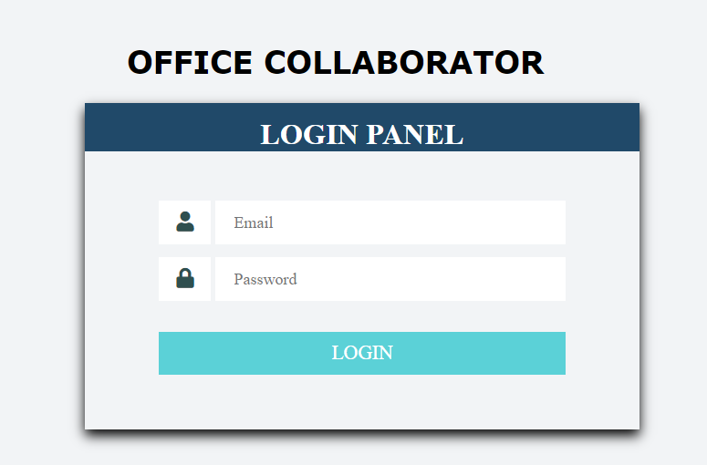

**Admin Panel**

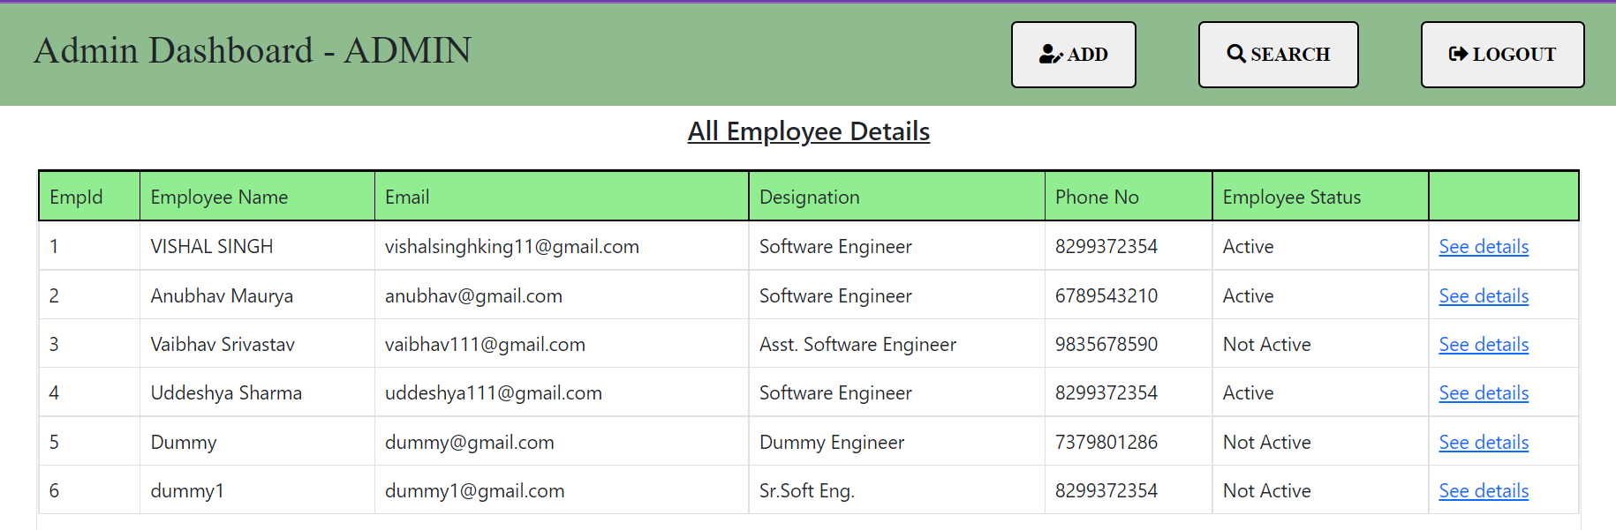

**Employee Registration form**

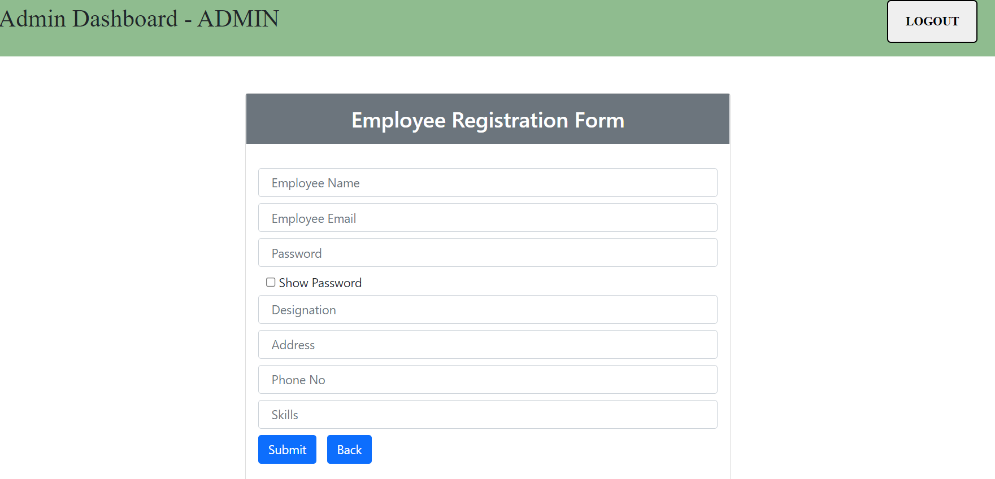

**Admin Panel Search**

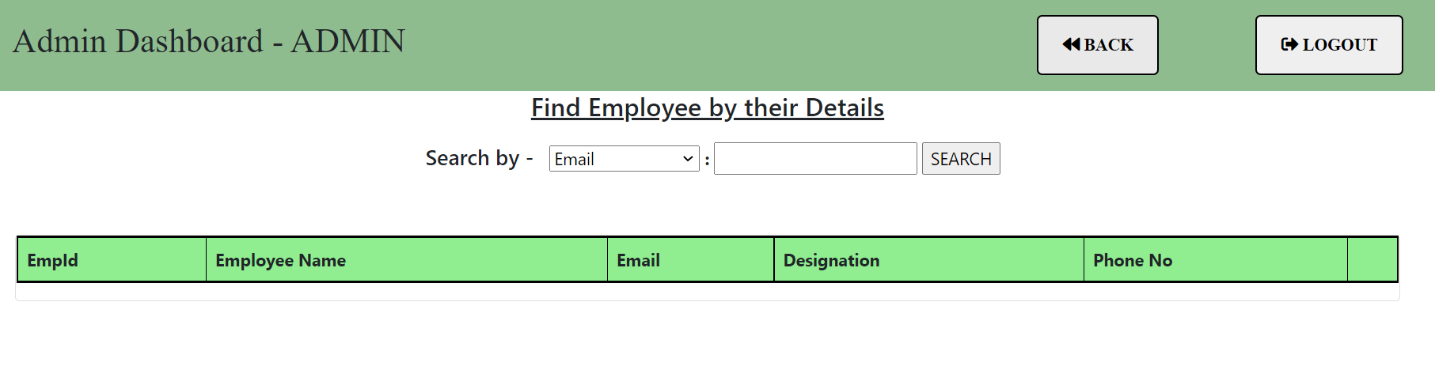

**Employee Dashboard**

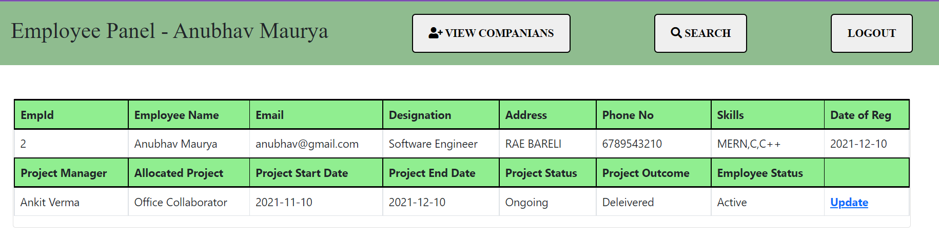

**Employee Project Companians**

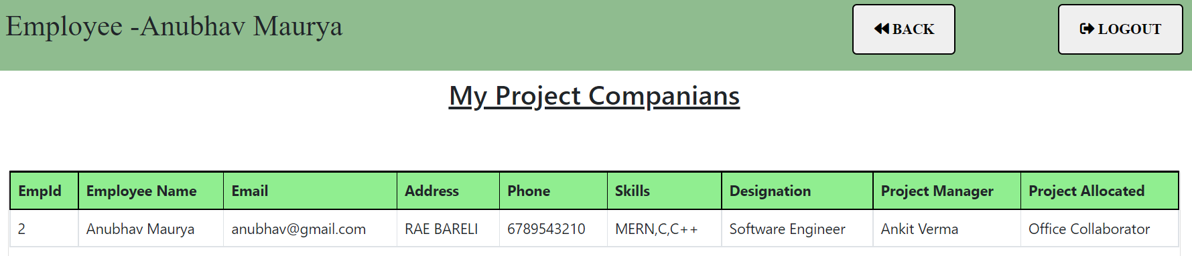

**Employee Panel Search**

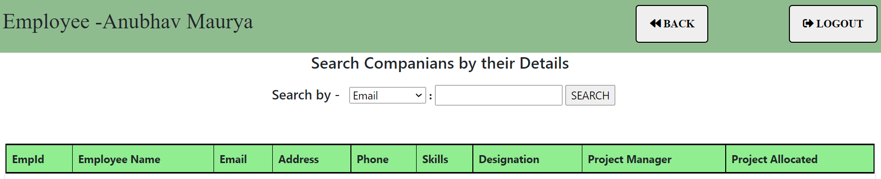

**Employee Own Details Update**

